Ongoing Improvements and Applications of the CERES-Rice Model

James Thigpen
February 16, 2018
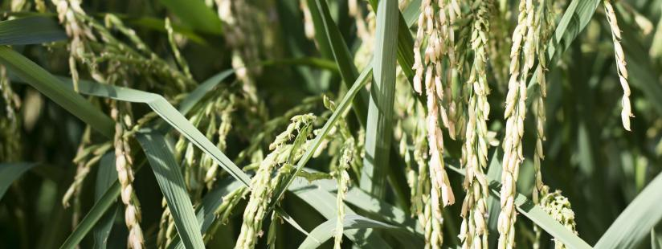
Photo: Greenhouse rice.
Rice is the most important cereal crop, and it is grown in a wide range of agro-environments, from temperate to tropical regions. It is also highly vulnerable to climatic variability and has a very low nutrient-use efficiency. Crop simulation models are an attractive option for understanding and predicting the effect of the multitude of factors and processes that affect rice growth. A literature review was undertaken to quantify the scope of use and the impact of the CERES-Rice model in research, teaching, extension and policy development.
Since its development in the early 1990s at the International Fertilizer Development Center (IFDC) through USAID funds, the CERES-Rice model has been applied to a wide range of focus areas, including crop management and shifting weather patterns. One of the main aims of this model is to ultimately (indirectly) help farmers by identifying major yield-limiting factors and thus prioritizing and developing research areas to improve cropping systems. The nearly 300 studies performed in 15 countries (see table below) utilizing the model have and will continue to increase our understanding of and decision-making in crop management (e.g., planting window, variety selection, planting density, irrigation options and nutrient rates), our assistance in agricultural policy development and our comprehension of and preparation for the impact of shifting weather patterns. To ensure CERES-Rice correctly simulates the effect of high temperature, drought and CO₂ change, a collaborative partnership between IFDC, the University of Florida, and the global Agricultural Model Intercomparison and Improvement Project (AgMIP) rice team has been developed.
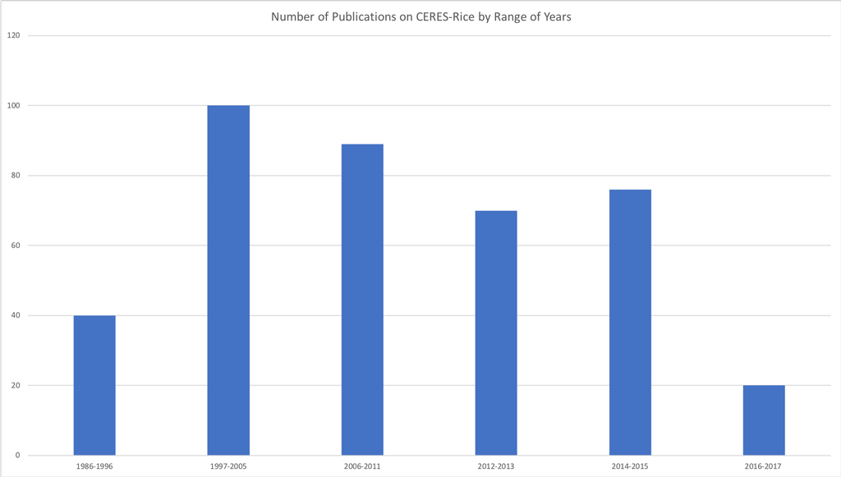

Graph: Yield Gap/Trend Analyses.
Since the early 1990s, the CERES-Rice model has been used to estimate yield potential and yield gaps and simulate yield trends. These analyses have been used to identify, from site-specific to national levels, constraints causing yield gaps and develop management strategies for closing them, such as adopting appropriate water and nitrogen management strategies. While models such as CERES-Rice simulate crop growth and development on a daily time step for a single growing season, research efforts have been made to analyze yield trends over longer timespans and across growing seasons to help address carryover issues such as water, soil organic matter and nutrient limitations.
Currently, crop modeling systems such as CERES-Rice represent the only research approach capable of considering the multitude of complex processes and interactions involved in crop production and cropping systems and will therefore continue to play a vital role in analyzing and developing potential pathways toward improving crop yields.

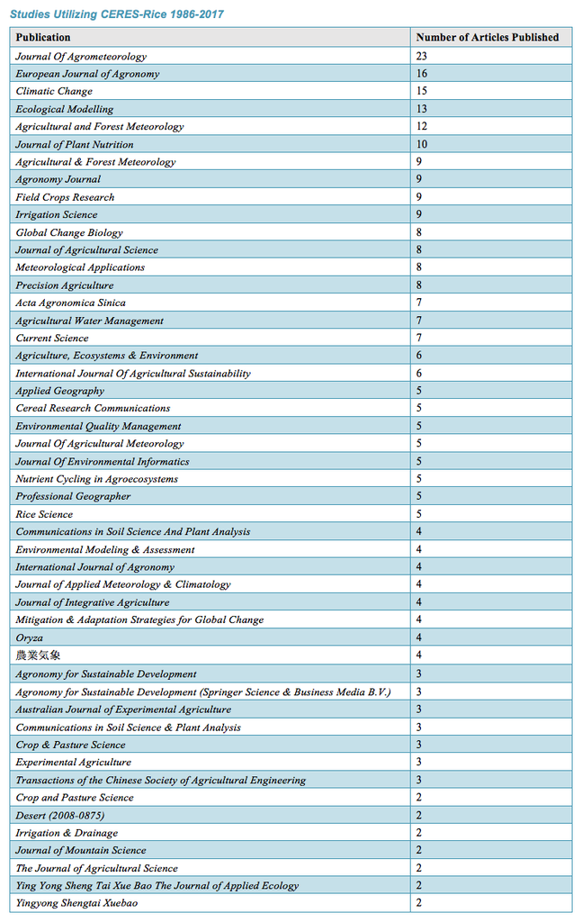
Improving Crop Management
Increasing yields requires not only the identification of potential constraints but developing solutions that address such constraints. CERES-Rice enables researchers to strategically, in real time, identify and implement crop management practices, such as irrigation and nitrogen management. The model has been used to evaluate management practices, allowing researchers to identify the effects of transplanting dates, planting geometry and nitrogen and water management.
These studies potentially enable researchers and policymakers to identify best management strategies to improve crop yields and minimize agricultural contributions to climate change, such as inappropriate water management and practices that increase nitrogen losses to groundwater and the atmosphere. In addition, some research on pest and disease management has been accomplished by pairing CERES-Rice with other models to evaluate yield impacts from these.
Shifting Climate Patterns
Far and wide, the bulk of the literature resulting from research performed using CERES-Rice focuses on the effects of climate change on rice production systems, including especially impacts on both irrigated and rain-fed rice yields and water use requirements in Asia.
These studies generated not only predictions regarding how shifting weather patterns will impact yields and resource use but also, and more importantly, management techniques to enable producers to adapt to these changes and inform policymakers to plan and implement climate-mitigating strategies for the present and future.
Models have enabled researchers to reliably predict yield responses to shifting weather patterns. With CERES-Rice specifically, researchers have used the model to quantify shifting weather patterns and CO₂ enrichment impacts on phenology, growth, yield, evapotranspiration, disease development and irrigation requirement of rice in multiple locations in more than nine countries across varying latitudes, giving a fuller glimpse of how future climate scenarios will affect crop production. These studies have yielded insights into how growth duration, planting date, fertilizer application, irrigation methods and varieties relate to climate change. The studies have provided for the ability to predict the effects of various expected scenarios and develop cropping strategies to cope with the changes.
The different applications of the CERES-Rice model are summarized below, and the role and impact of modeling will expand with increasing vulnerability to climatic variabilities and uncertainties. Through university partnerships and working with the AgMIP rice team, efforts are underway to evaluate the CERES-Rice model for a wide range of temperatures, CO₂ levels and N rates from studies that have been conducted in the past.
